Project: Hazardous Gass Detection System Name:-Deepak Kumar

Roll no**.-21781A04M7**

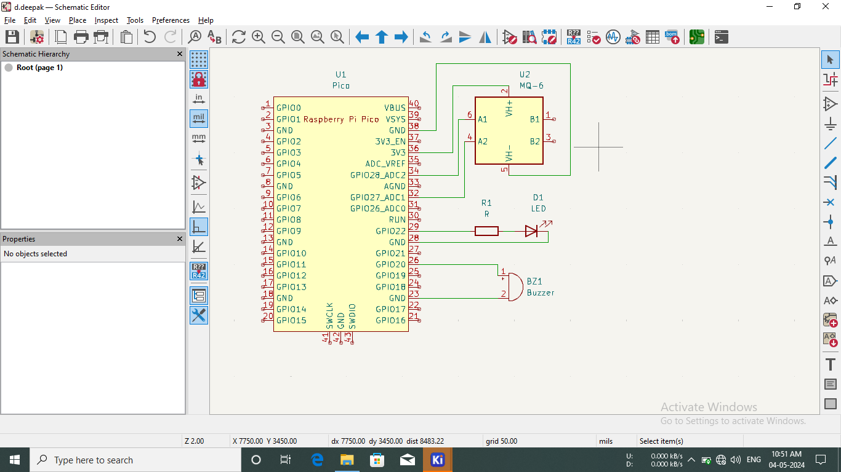

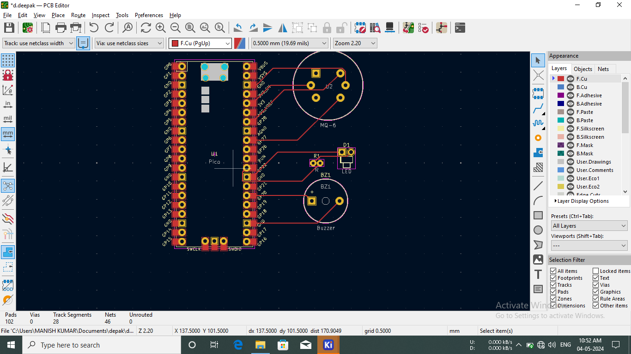

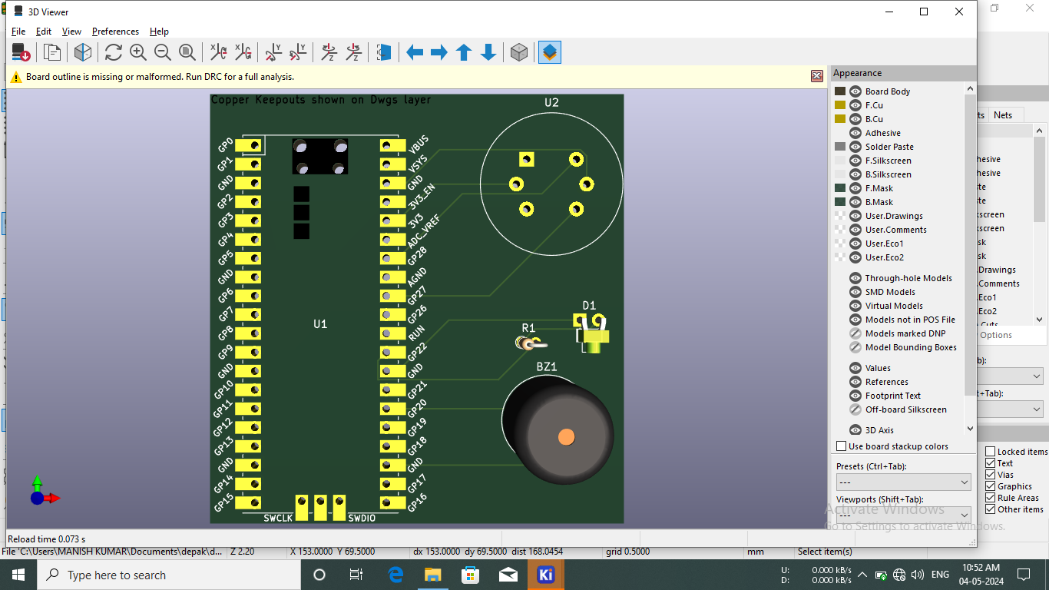

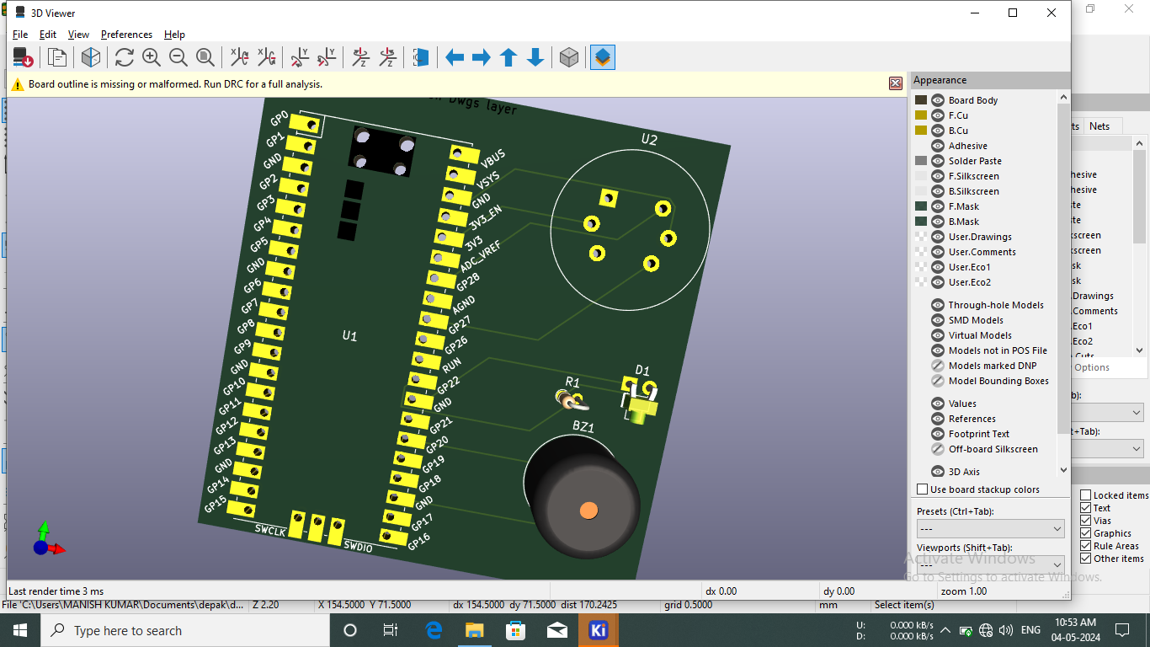

2. Project

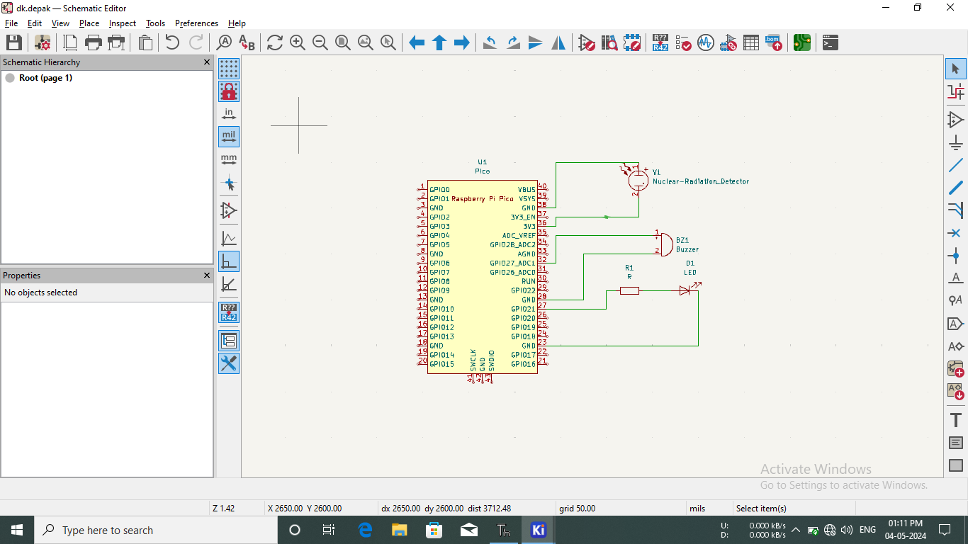

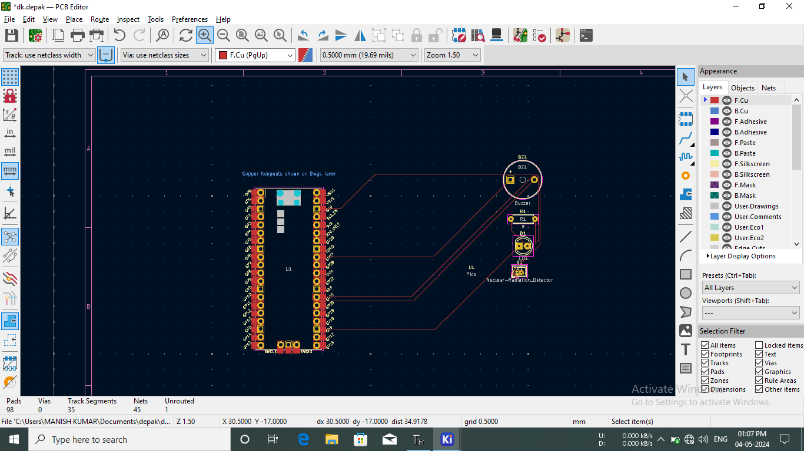

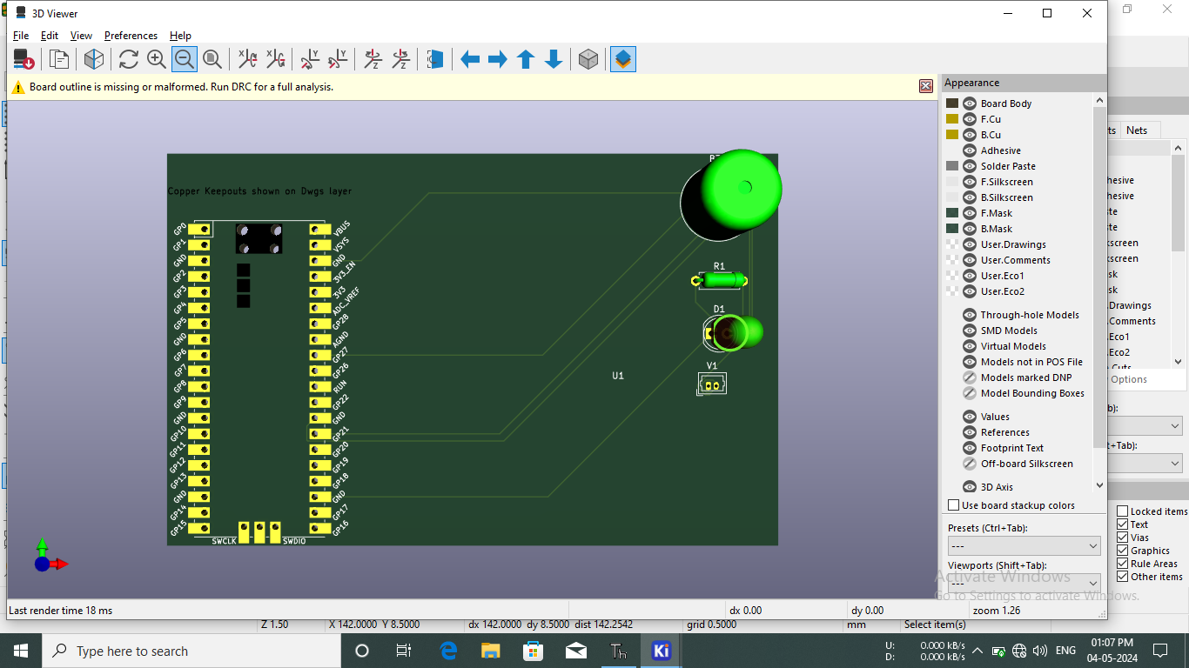

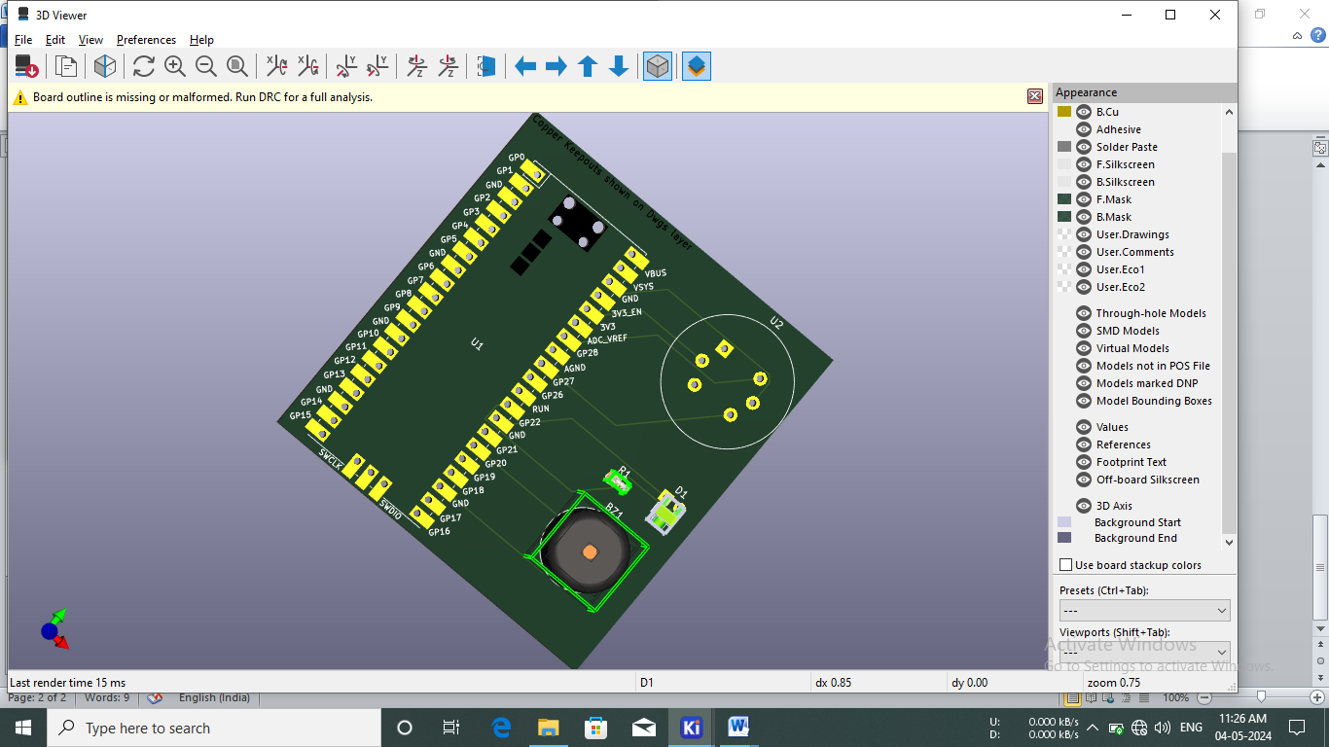

Project:- 3

PROGRAM:-

1 import machine

2 import time

3

4 # Define pin numbers

5 PIR _PIN = machine. Pin (27, machine.Pin.IN)

6 BUZZER _PIN machine. Pin (6, machine.Pin.OUT)

8 # Function to activate the buzzer

9 def activate_buzzer():

10 BUZZER_PIN.on()

11 time.sleep(0.5)

12 BUZZER_PIN.off()

13

14

15 #mMain loop to detected motion

#Keep buzzer on for 0.5 seconds

#Turn buzzer off

15 Main loop to detect motion

16 while True:

17 if PIR PIN.value(): # PIR sensor detects motion

18 print("Motion detected!")

19 activate_buzzer()

20 time.sleep(0.2)

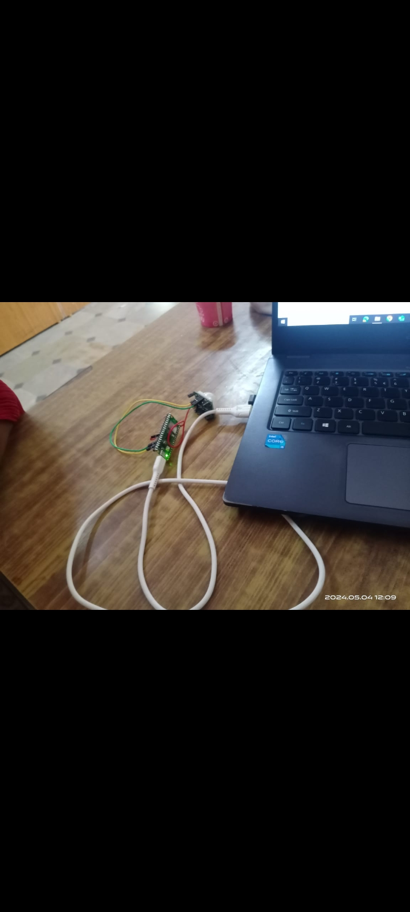

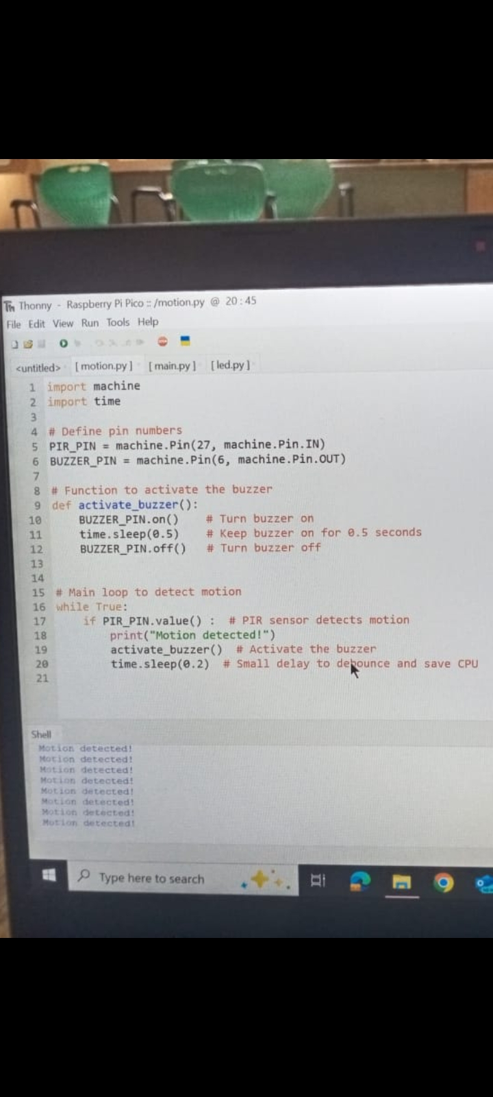

***Thank You***